Student Name : Sankar Samiksha

Group : SS5

Date : 5 April 2022

LAB 4: ANALZING NETWORK DATA LOG

You are provided with the data file, in .csv format, in the working directory. Write the program to extract the following informations.

Exercise 4A: TOp TALKERS and LISTENERS

One of the most commonly used function in analyzing data log is finding out the IP address of the hosts that send out large amount of packet and hosts that receive large number of packets, usually know as TOP TALKERS and LISTENERS. Based on the IP address we can obtained the organization who owns the IP address.

List the TOP 5 TALKERS

Rank | IP address | # of packets | Organisation
1 | 193.62.192.8 | 3041 | European Bioinformatics, England
2 | 155.69.160.32 | 2975 | NTU, Singapore
3 | 130.14.250.11 | 2604 | National Library of Medicine, United States
4 | 14.139.196.58 | 2452 | Indian Institute of Technology (IIT) Guwahati, India
5 | 140.112.8.139 | 2056 | Taiwan Academic Network, Taiwan

TOP 5 LISTENERS

Rank | IP address | # of packets | Organisation
1 | 103.37.198.100 | 3841 | A*STAR, Singapore
2 | 137.132.228.15 | 3715 | NUS, Singapore
3 | 202.21.159.244 | 2446 | Republic Polytechnic, Singapore
4 | 192.101.107.153 | 2368 | Pacific Northwest National Laboratory, United States
5 | 103.21.126.2 | 2056 | Indian Institute of Technology, Bombay

Exercise 4B: TRANSPORT PROTOCOL

Using the IP protocol type attribute, determine the percentage of TCP and UDP protocol

 | Header value | Transport layer protocol | # of packets
1 | 6 | TCP | 56064
2 | 17 | UDP | 9462
3 | 50 | ESP | 1698

Total Number of Packets in the entire CSV: 68065
Percentage of UDP: 13.901417762432969%
Percentage of TCP: 82.36832439579813%

Exercise 4C: ApplicationS PROTOCOL

Using the Destination IP port number determine the most frequently used application protocol.
(For finding the service given the port number https://www.adminsub.net/tcp-udp-port-finder/ )

Rank | Destination IP port number | # of packets | Service
1 | 443 | 13423 | HTTPS (Hypertext Transfer Protocol over SSL/TLS)
2 | 80 | 2647 | http  (Hypertext Tranfer Protocol)
3 | 52866 | 2068 | Dynamic and/or private ports (UDP or TCP)  Xsan. Xsan Filesystem Access(TCP)
4 | 45512 | 1356 | Unassigned
5 | 56152 | 1341 | Dynamic and/or private ports (UDP or TCP)  Xsan. Xsan Filesystem Access(TCP)

Exercise 4D: Traffic

The traffic intensity is an important parameter that a network engineer needs to monitor closely to determine if there is congestion. You would use the IP packet size to calculate the estimated total traffic over the monitored period of 15 seconds. (Assume the sampling rate is 1 in 2048)

IP packet size corresponds to the IP_Size column name

Total Traffic( MB) | 126519.18359375 MB (to 2 d.p)
Exercise 4E: ADDITIONAL ANALYSIS

Please append ONE page to provide additional analysis of the data and the insight it provides.
Examples include:
Top 5 communication pairs;
Visualization of communications between different IP hosts;
etc.
Please limit your results within one page (and any additional results that fall beyond one page limit will not be assessed).
The top 5 communication pairs
IP Address 1 | ISP | IP Address 2 | ISP | Count
137.132.228.15 | NUS | 193.62.192.8 | European Bioinformatics Institute | 4951
130.14.250.11 | National Library of Medicine | 103.37.198.100 | A*STAR | 2842
14.139.196.58 | Indian Institute of Technology (IIT) Guwahati | 192.101.107.153 | Pacific Northwest National Laboratory | 2368
103.21.126.2 | Indian Institute of Technology, Bombay | 140.112.8.139 | Taiwan Academic Network | 2056
167.205.52.8 | Institut Teknologi Bandung | 140.90.101.61 | National Oceanic and Atmospheric Administration | 1752

Using the table of communication pairs the network graph below was plotted. The graph is very sparse and most nodes are only connected to one other node. The image in the right is a zoomed in version. The thickness of the line indicates the count or the amount the two ip addresses have interacted with each other.
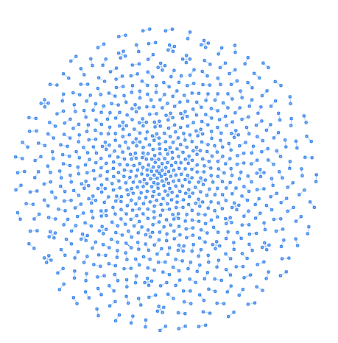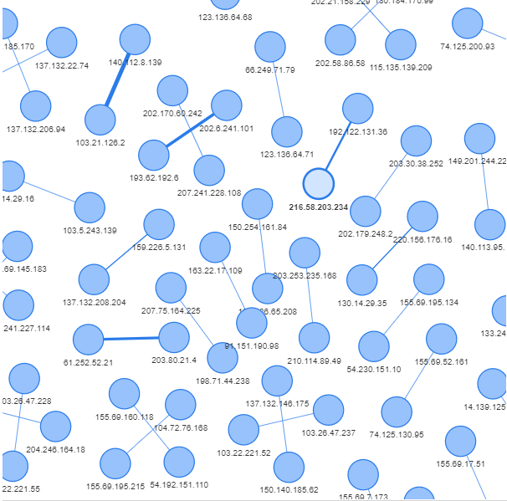
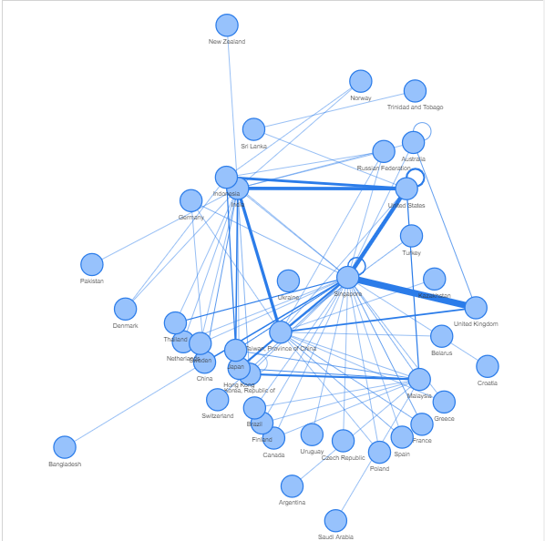

Later, the ip addresses were grouped accordingly the country of origin. On the left shows the graph:
A hollow circle indicates that the two ip addresses interacting with each other come from the same country. Similar to earlier, the thicker the line, the more the interaction. Here we can see that Singapore interacts most with United Kingdom followed by United States.

Exercise 4F: SOFTWARE CODE

Please also submit your code to the NTULearn lab site.

